**Lab: File Input/Output**

**Lab Task 1:**

**Problem 1.d from Text Book.**

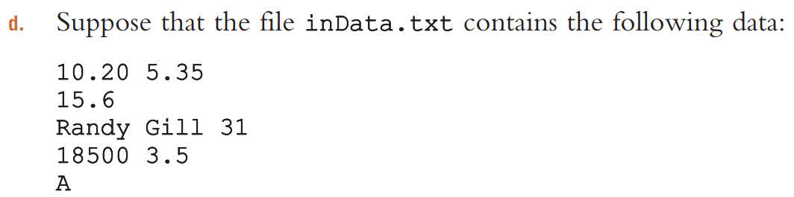

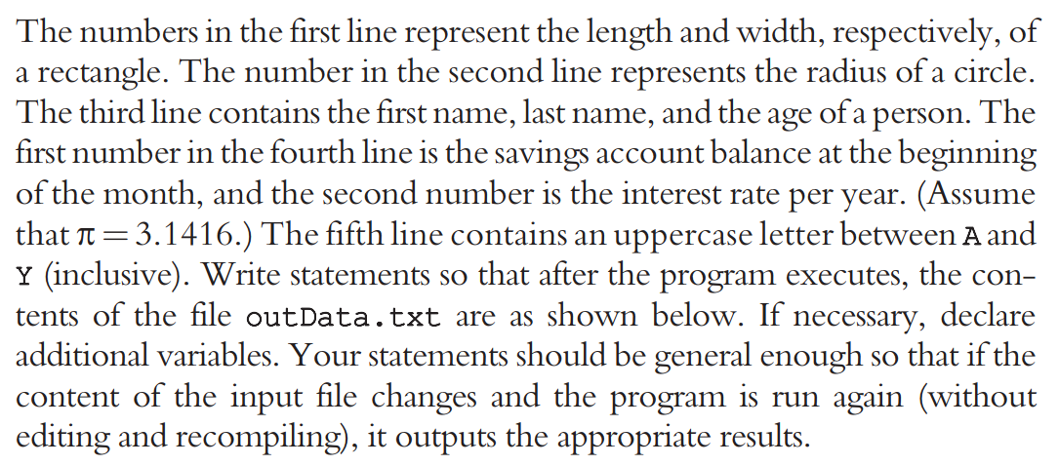

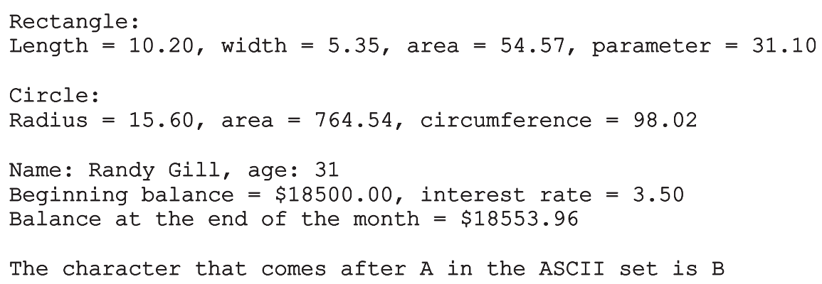

**HOME TASKS:**

1. Problem 8 from Text Book.
2. Problem 10 from Text Book.